DISILLUSIONED

BY AN EX-ENTHUSIAST

By W. S. Gilbert
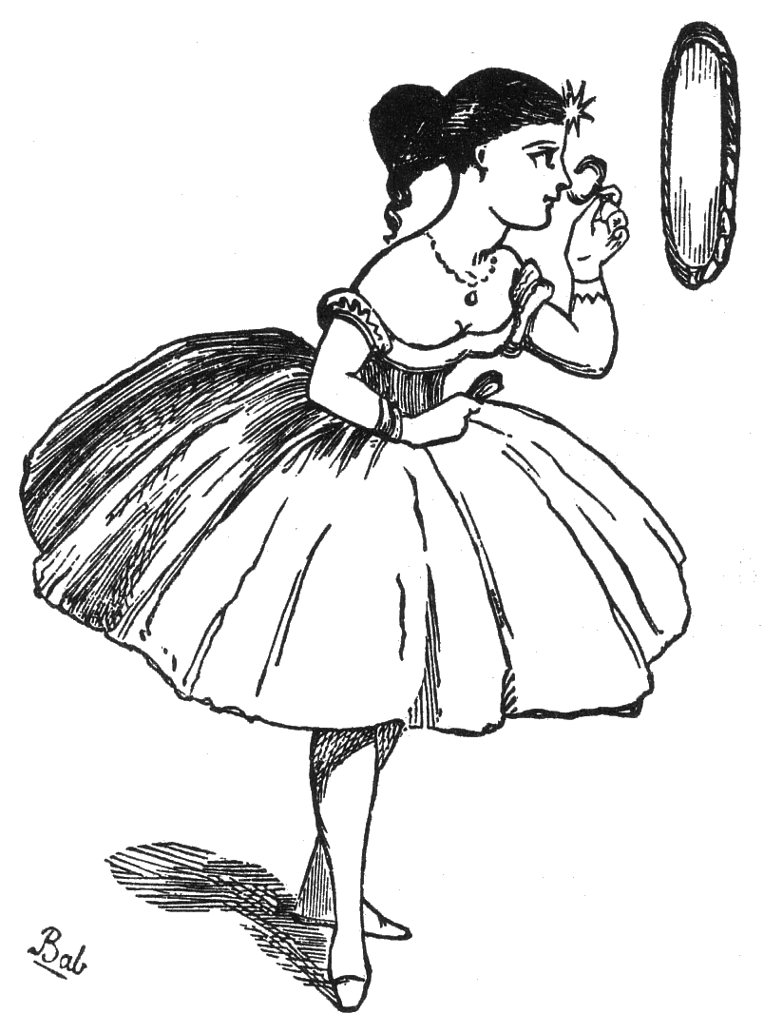
Oh, that my soul its gods could see
As years ago they seemed to me
When first I painted them;
Invested with the circumstance
Of old conventional romance:
Exploded theorem!

The bard who could, all men above,
Inflame my soul with songs of love,
And, with his verse, inspire
The craven soul who feared to die
With all the glow of chivalry
And old heroic fire;

I found him in a beerhouse tap
Awaking from a gin-born nap,
With pipe and sloven dress;
Amusing chums, who fooled his bent,
With muddy, maudlin sentiment,
And tipsy foolishness!

The novelist, whose painting pen
To legions of fictitious men
A real existence lends,
Brain-people whom we rarely fail,
Whene'er we hear their names, to hail
As old and welcome friends;

I found in clumsy snuffy suit,
In seedy glove, and blucher boot,
Uncomfortably big.
Particularly commonplace,
With vulgar, coarse, stockbroking face,
And spectacles and wig.

My favourite actor who, at will,
With mimic woe my eyes could fill
With unaccustomed brine:
A being who appeared to me
(Before I knew him well) to be
A song incarnadine;

I found a coarse unpleasant man
With speckled chin--unhealthy, wan--
Of self-importance full:
Existing in an atmosphere
That reeked of gin and pipes and beer--
Conceited, fractious, dull.
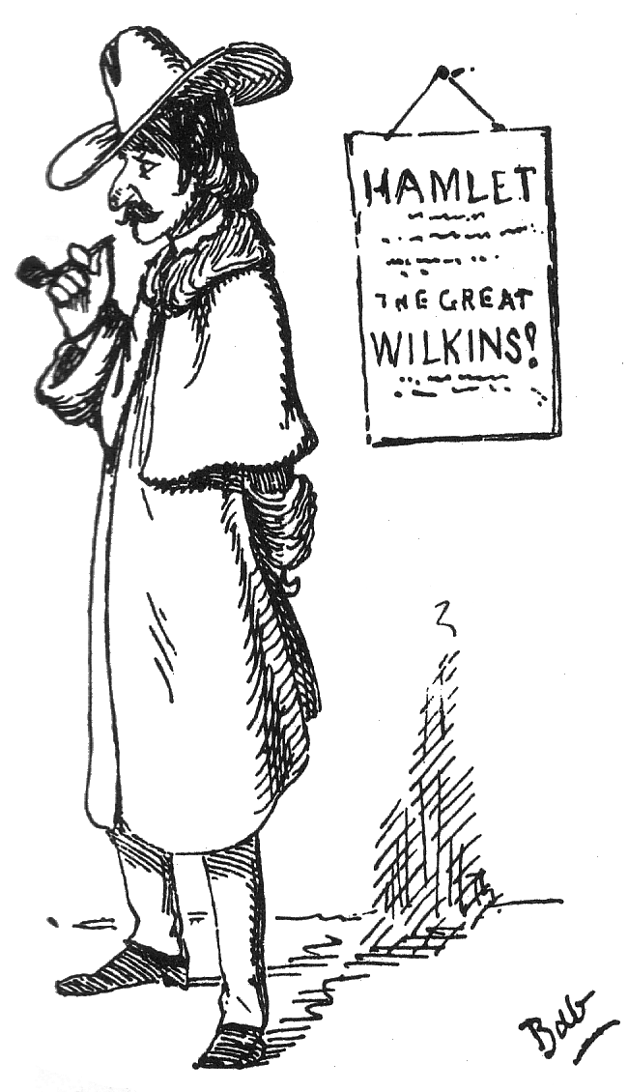
The warrior whose ennobled name
Is woven with his country's fame,
Triumphant over all,
I found weak, palsied, bloated, blear;
His province seemed to be, to leer
At bonnets in Pall Mall.

Would that ye always shone, who write,
Bathed in your own innate limelight,
And ye who battles wage,
Or that in darkness I had died
Before my soul had ever sighed
To see you off the stage!

Fun Vol. V, 6 July 1867

